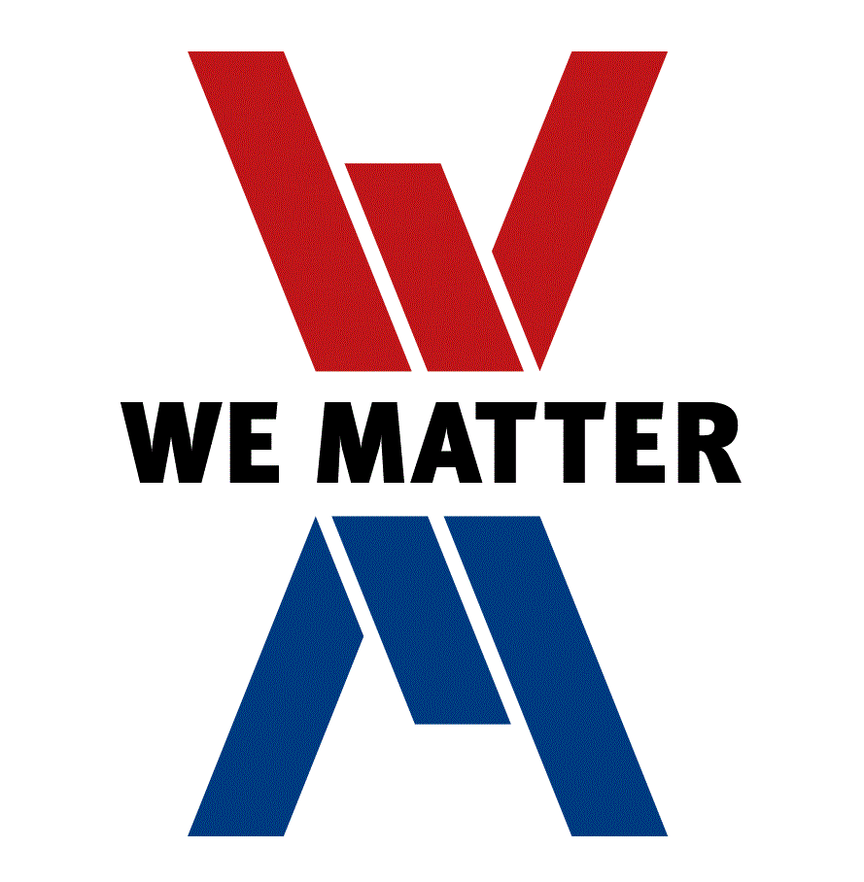**SRAS Staff AGREEMENT**

SRAS is a **WeMatter** site. This means that staff will:

* Actively encourage the school community to develop a shared understanding of Mental Health and Wellbeing
* Model our values and demonstrate respectful relationships that foster a sense of belonging and inclusion within the school community
* Be consistent, caring and collaborative in building and maintaining a welcoming school environment that is inclusive of all stakeholders
* Promote positive and active involvement of students, peers, families and local community in SRAS